Exam 1 Name:_____________________________
March 8, 2007 I agree to observe the Wake Forest
Chm 122 Honor Code during this exam.
75 minutes
100 points

Instructions: There are 11 questions and two bonuses on the following pages. Check the exam now to be sure that you have all 11 questions. There are two blank pages to be used as scratch paper at the end of the exam. You may remove these pages, as needed, but all answers must appear on the same page as the question and, where appropriate, in the designated space.

Write your name, clearly, in the space provided above.

Each question contains several parts. Be sure to completely read each question so that you answer all parts!

Do not hesitate to ask a question if it arises.

Clearly answer each question - if it is unclear what you intended to answer, the problem will be counted wrong. You have 75 minutes to complete the exam. I advise that you work through the exam once answering what you know and save problems you are unsure of for the end of the period. Exams will be collected, promptly, 75 minutes after they are distributed.

The bonus problems are challenging and little partial credit will be awarded. I recommend you not work these until you are satisfied that you have done all you can on the rest of the exam.

You are expected to abide by the Wake Forest University Honor Code and the rules of decency. Any violations of the Honor Code will be pursued through all necessary means.

Good luck.
1. Draw Newman projections, looking down the indicated (arrow) bond, for the most stable and least stable conformations of this molecule. Name this compound according to IUPAC rules. Draw an enantiomer of the molecule and assign an absolute configuration to any chiral centers. If possible, draw a diastereomer of the molecule; if not, state that it isn’t possible. How many signals would appear in the ¹³C NMR spectrum of this molecule? What is the relationship of H_{a} and H_{b} (i.e. are they homotopic, enantiotopic, diastereotopic or simply different)? 14 points

IUPAC Name:

Most Stable Conformation Least Stable Conformation

2. In the boxes provided, draw the structure of a molecule having the molecular formula C₄H₆O₂ and the functional group indicated. How many degrees of unsaturation are present in these molecules? Which compound has the lowest pKa? 8 points

Degrees of Unsaturation:

3. In each pair, indicate if the relationship of the two molecules is that they are identical, constitutional isomers, enantiomers, diastereomers or that they are the same meso structure. 10 pts

4. Draw the molecule shown below in its most stable chair form. 15 points

Assign an absolute configuration to any chiral centers.

How are the two methyl groups related (homotopic, enantiotopic, diastereotopic, unrelated)?

How many signals would appear in the ¹³C NMR spectrum for this molecule?

When a ¹H NMR spectrum of this molecule is obtained, there is a signal at δ 5.1 that integrates for one proton and is a doublet of doublet of doublets. There is another signal that integrates for one proton at δ 3.7 that is a doublet. Upon addition of D₂O, the signal at δ 3.7 disappears and the signal at δ 5.1 becomes a doublet of doublets.

Assign a proton in the molecule to each of the signals (δ 3.7 and δ 5.1).
Explain why the signal at δ 3.7 disappears upon addition of D₂O.
Explain why the splitting of the signal at δ 5.1 simplifies upon addition of D₂O.

5. Write the name of the enantiomer of (+)-(2R)-methyl-(1S)-cyclohexanol. If [α]_{D} = +28º for that compound, what is the observed rotation of plane polarized light that is 50 %ee of the other enantiomer? 6 points

6. Identify the protons in lauric acid that give rise to the following resonances. 6 points

δ 12.4, broad singlet, exchanges with D₂O – this is the most downfield signal

δ 0.87, triplet – this is the most upfield signal in the spectrum

7. Briefly describe how you would distinguish these two compounds using ¹³C NMR. 4 points

8. Reduction of the C=O double bond to a C-O single bond in the reaction shown below can be easily accomplished. The starting material was 100 %ee S enantiomer at the chiral center.

When a chemist carried out this reaction with a chiral catalyst, a product was obtained that did not rotate plane polarized light. Briefly explain why the product does not rotate plane polarized light and re-draw the product to show the correct stereochemistry at the new chiral carbon. 7 points

9. Which of the following molecules is responsible for the IR spectrum shown below? Explain your reasoning. 10 points

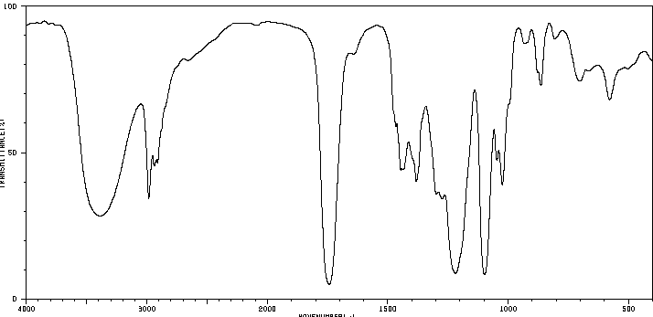

10. Draw a more stable resonance structure of this ion. 4 points

11. Draw the most likely acid/base reaction between the two molecules below. Identify the acid, the base, the conjugate acid and the conjugate base. Draw a mechanism illustrating how the reaction occurs. Which side of the equilibrium is favored? Draw a reaction energy diagram consistent with this reaction and label reactants, products and transition state on the diagram. Does the transition state look more like reactants or products and what does this imply about the bonding to the acidic H in the transition state? 16 points

Bonus 1. Three mild acids are shown below along with their pKa. Which is the most acidic (1 point)? Which is least acidic (1 point)? Briefly explain why these compounds vary in acidity and why the most acidic is more acidic than the others. 5 points

Bonus 2. What is the structure (C₉H₁₂O) of the compound that produced these spectra? 8 points
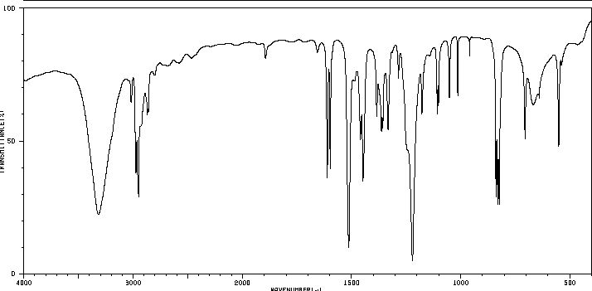
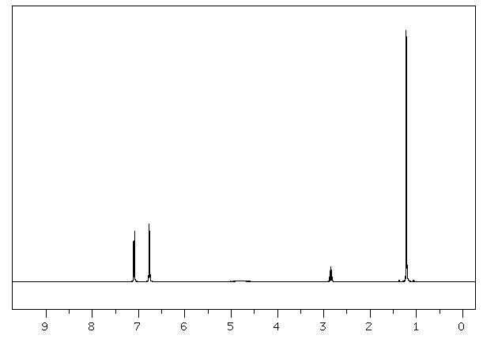
d d bs septet d
2 2 1 1 6
